**Compare one csv file with multiple json file**

import pathlib  
import sys,pandas as pd  
import os  
import json  
  
inputpath = pathlib.Path(sys.argv[1])  
configpath = pathlib.Path(sys.argv[2])  
outputpath = pathlib.Path(sys.argv[3])  
  
'''json config file store in array'''  
configfle = []  
for file in os.listdir(configpath):  
 full_filename = "%s/%s" % (configpath, file)  
 with open(full_filename,'r') as fi:  
 dict = json.load(fi)  
 d = dict['column']  
 configfle.append(d)  
print(configfle)  
  
'''input file store in array'''  
  
inputfile = []  
for file in os.listdir(inputpath):  
 full_filename1 = "%s/%s" % (inputpath, file)  
 with open(full_filename1,'r') as fi1:  
 dict1 = pd.read_csv(fi1)  
 inputfile.append(dict1)  
   
'''inputfile[0] is getting only column names'''  
input = list(inputfile[0].columns)  
print(input)  
  
'''inputfile[0] check in configfile if matches , it create new csv file '''  
for input in configfle:  
  
 output = inputfile[0]  
 output.to_csv(sys.argv[3])

OUTPUT:

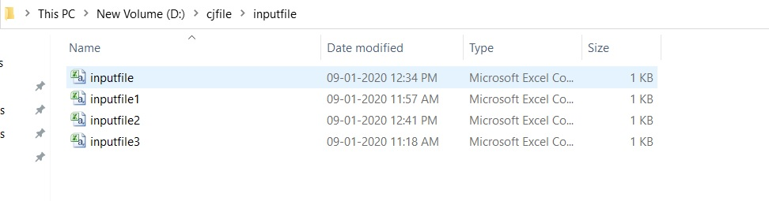

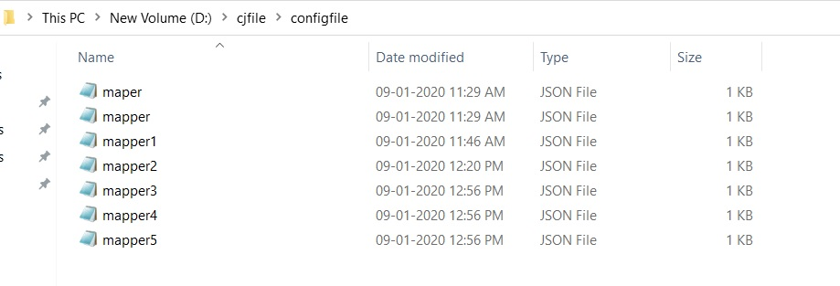

SAMPLE OUTPUT:

